
Alpha-particle tracks
Nuclear “bullets” from radioactive atoms make the tracks in a cloud chamber. They hurtle through the air, “wet” with alcohol vapour, detaching an electron from atom after atom and leaving a trail of ions in their path. Tiny drops of alcohol can easily form on these ions to mark the trail.
The trail of ions is made up of some “air molecules” that have lost an electron (leaving them with a positive charge) and some that have picked up the freed electrons, giving them a negative charge.
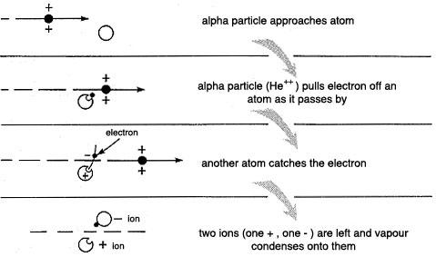
There is no sighting of the particle that caused the ionisation because it has left the scene before the condensation happens. If you count the number of droplets then an alpha particle might produce 100 000 pairs of ions by pulling an electron from
100 000 atoms.
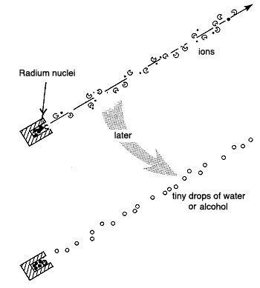
Nucleur “bullets” forming a trail of ions, which are condensation nuclei
This is rather like a cannon ball that is fired through a field of ripe wheat. If you are watching from a helicopter, the ball moves too fast for you to see it and you will hardly notice the trail of broken stalks. Wait a few minutes and the track will be marked by a line of dark birds settled on the broken stalks. (This story is said to be due to Andrade.)
When the alpha particle has lost all of its energy in collisions with the “air molecules”, it stops moving and is absorbed.

